## Jerusalem, Millennial and Eternal

There is a great contrast between the Millennial Jerusalem and the Eternal Jerusalem.

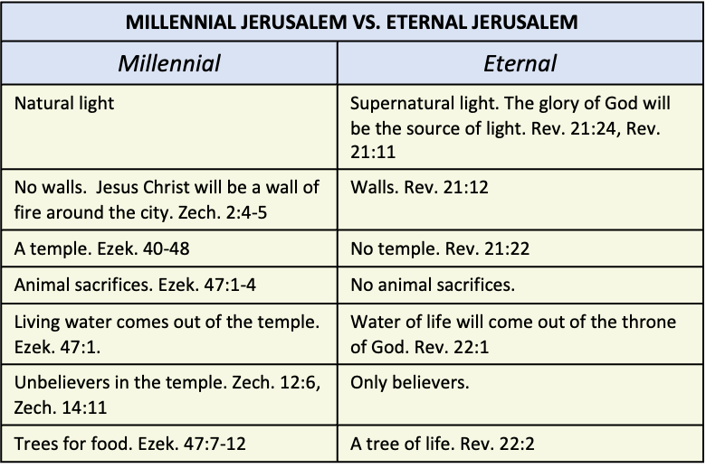

**Millennial Jerusalem**

The Jerusalem of the Millennium is described in Zechariah 2 and Ezekiel 40-48. There will be natural light with no walls. Instead, there Our Lord will be a wall of fire around the city. Zech. 2:4-5.

“and said to him, "Run, speak to that young man, saying, 'Jerusalem will be inhabited without walls because of the multitude of men and cattle within it. 'For I,' declares the LORD, 'will be a wall of fire around her, and I will be the glory in her midst.'"” (Zechariah 2:4-5, NASB)

There will be a temple. Ezek. 40-48

There will be animal sacrifices. Ezek. 47:1-4.

“Then he brought me back to the door of the house; and behold, water was flowing from under the threshold of the house toward the east, for the house faced east. And the water was flowing down from under, from the right side of the house, from south of the altar. He brought me out by way of the north gate and led me around on the outside to the outer gate by way of the gate that faces east. And behold, water was trickling from the south side. When the man went out toward the east with a line in his hand, he measured a thousand cubits, and he led me through the water, water reaching the ankles. Again he measured a thousand and led me through the water, water reaching the knees. Again he measured a thousand and led me through the water, water reaching the loins.” (Ezekiel 47:1-4, NASB)

Living water will come out of the temple in the Millennial Jerusalem. Ezek. 47:1.

“Then he brought me back to the door of the house; and behold, water was flowing from under the threshold of the house toward the east, for the house faced east. And the water was flowing down from under, from the right side of the house, from south of the altar.” (Ezekiel 47:1, NASB)

There will be unbelievers in the Millennial temple. Zech. 12:6, Zech. 14:11.

“"In that day I will make the clans of Judah like a firepot among pieces of wood and a flaming torch among sheaves, so they will consume on the right hand and on the left all the surrounding peoples, while the inhabitants of Jerusalem again dwell on their own sites in Jerusalem.” (Zechariah 12:6, NASB)

“People will live in it, and there will no longer be a curse, for Jerusalem will dwell in security.” (Zechariah 14:11, NASB)

There will be trees for food. Ezek. 47:7-12.

“"By the river on its bank, on one side and on the other, will grow all kinds of trees for food. Their leaves will not wither and their fruit will not fail. They will bear every month because their water flows from the sanctuary, and their fruit will be for food and their leaves for healing."” (Ezekiel 47:12, NASB)

**Eternal Jerusalem**

The Eternal Jerusalem is described in Revelation 21:9 through Revelation 22:5. Jerusalem will have supernatural light. Rev. 21:11.

“And he carried me away in the Spirit to a great and high mountain, and showed me the holy city, Jerusalem, coming down out of heaven from God, having the glory of God. Her brilliance was like a very costly stone, as a stone of crystal-clear jasper.” (Revelation 21:10-11, NASB)

There will be walls in eternal Jerusalem. Rev. 21:12. There will be no temple in the eternal Jerusalem. Rev. 21:22.

“It had a great and high wall, with twelve gates, and at the gates twelve angels; and names were written on them, which are the names of the twelve tribes of the sons of Israel.” (Revelation 21:12, NASB)

“I saw no temple in it, for the Lord God the Almighty and the Lamb are its temple.” (Revelation 21:22, NASB)

There will be no animal sacrifices. Water of life will come out of the throne of God in the New Jerusalem. Rev. 22:1.

“Then he showed me a river of the water of life, clear as crystal, coming from the throne of God and of the Lamb,” (Revelation 22:1, NASB)

Only believers will live in the New Jerusalem. The glory of God will be the source of light. Rev. 21:24.

“And the city has no need of the sun or of the moon to shine on it, for the glory of God has illumined it, and its lamp is the Lamb. The nations will walk by its light, and the kings of the earth will bring their glory into it.” (Revelation 21:23-24, NASB)

There will be a tree of life. Rev. 22:2.

“in the middle of its street. On either side of the river was the tree of life, bearing twelve kinds of fruit, yielding its fruit every month; and the leaves of the tree were for the healing of the nations.” (Revelation 22:2, NASB)